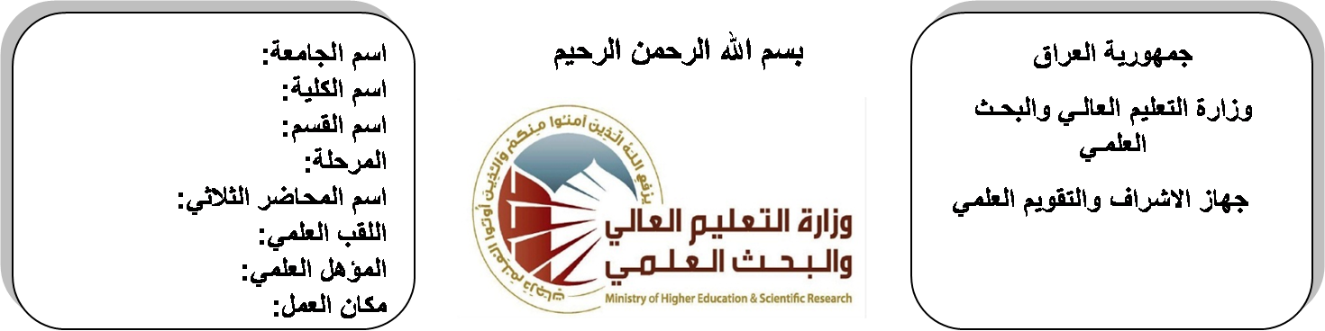

**University: Diyala University**

**College: College of Engineering**

**Department: Electronic Engineering**

**Stage: Second**

**Lecturer name:** **Ibrahim Saadoon Fatah**

**Qualification: M.Sc**

**Place of work: Electronic Dept.**

**Republic of Iraq**

**Ministry of Higher Education**

**& Scientific Research**

**(( Annual teaching plan form))**

|  |  |  |  |  |
| --- | --- | --- | --- | --- |
| **Lecturer Name** | **Ibrahim Saadoon Fatah** | | | |
| **Email** | ibrahim1969@yahoo.com | | | |
| **Subject** | **Electrical Power & Machines** | | | |
| **Aims** | **The aim of this subject is to make the students ready to undestand and comprehend the scientific theories and their applications related to their field of the study.** | | | |
| **Textbooks** | **Electrical Technology by B.L Theraja.** | | | |
| **Additional Textbooks** |  | | | |
| **Assessments** | **First Semester** | **Second Semester** | **Laboratory** | **Final Exam** |
| 20% | 20% | 10% | 50% |
| **Notes** |  | | | |

**Schedule Weekly Lessons - First Semester**

|  |  |  |  |  |
| --- | --- | --- | --- | --- |
| **Week** | **Date** | **Lectures** | **Lab. Experments** | **Notes** |
| 1 | **30/9** | Construction of D-C machine |  |  |
| 2 | **7/10** | Direct current generator and motor principles |  |  |
| 3 | **14/10** | Principles of generator action, Types of D-G generators |  |  |
| 4 | **21/10** | Shunt D-Generator series D-C generators |  |  |
| 5 | **28/10** | Types of D-C motors |  |  |
| 6 | **4/11** | Shunt D-C motors, Series D-C motors |  |  |
| 7 | **11/11** | Compound D-C motors, Separately excited D-C motor, Shunt D-C motors |  |  |
| 8 | **18/11** | Compound D-C Motors |  |  |
| 9 | **25/11** | Construction of transformer |  |  |
| 10 | **2/12** | Fundamental principle of operation of ideal Tr |  |  |
| 11 | **9/12** | Approximate equivalent circuit  Voltage regulation |  |  |
| 12 | **16/12** | Transformer efficiency, Open circuit test, Short circuit test |  |  |
| 13 | **23/12** | Transformer efficiency, Open circuit test, Short circuit test |  |  |
| 14 | **30/12** | Transformer efficiency, Open circuit test, Short circuit test |  |  |
| 15 | **6/1** | Transformer efficiency, Open circuit test, Short circuit test |  |  |
| 16 | **13/1** | Transformer efficiency, Open circuit test, Short circuit test |  |  |
| Half Year holiday | 15/1 to  1/2 |  |  |  |

**Lecturer Signature Head of Dept. Signature Dean Signature**

**Schedule Weekly Lessons - Second Semester**

|  |  |  |  |  |
| --- | --- | --- | --- | --- |
| **Week** | **Date** | **Lectures** | **Lab. Experments** | **Notes** |
| 1 | **17/2** | . **Electrical Power** |  |  |
| 2 | **24/2** | **Electrical Power** |  |  |
| 3 | **2/3** | Power definition |  |  |
| 4 | **9/3** | Power in 1-cct |  |  |
| 5 | **16/3** | Power in 1-cct |  |  |
| 6 | **23/3** | Power in 3-cct |  |  |
| 7 | **30/3** | Power in 3-cct |  |  |
| 8 | **6/4** | Power plant over head transmission line |  |  |
| 9 | **13/4** | Power plant over head transmission line |  |  |
| 10 | **20/4** | Power plant over head transmission line |  |  |
| 11 | **27/4** | Conductor material |  |  |
| 12 | **4/5** | Conductor material |  |  |
| 13 | **11/5** | Conductor material |  |  |
| 14 | **19/5** | Material design sag tension relationship |  |  |
| 15 | **26/5** | Material design sag tension relationship |  |  |
| 16 | **3/6** | Material design sag tension relationship |  |  |

**Lecturer Signature Head of Dept. Signature Dean Signature**